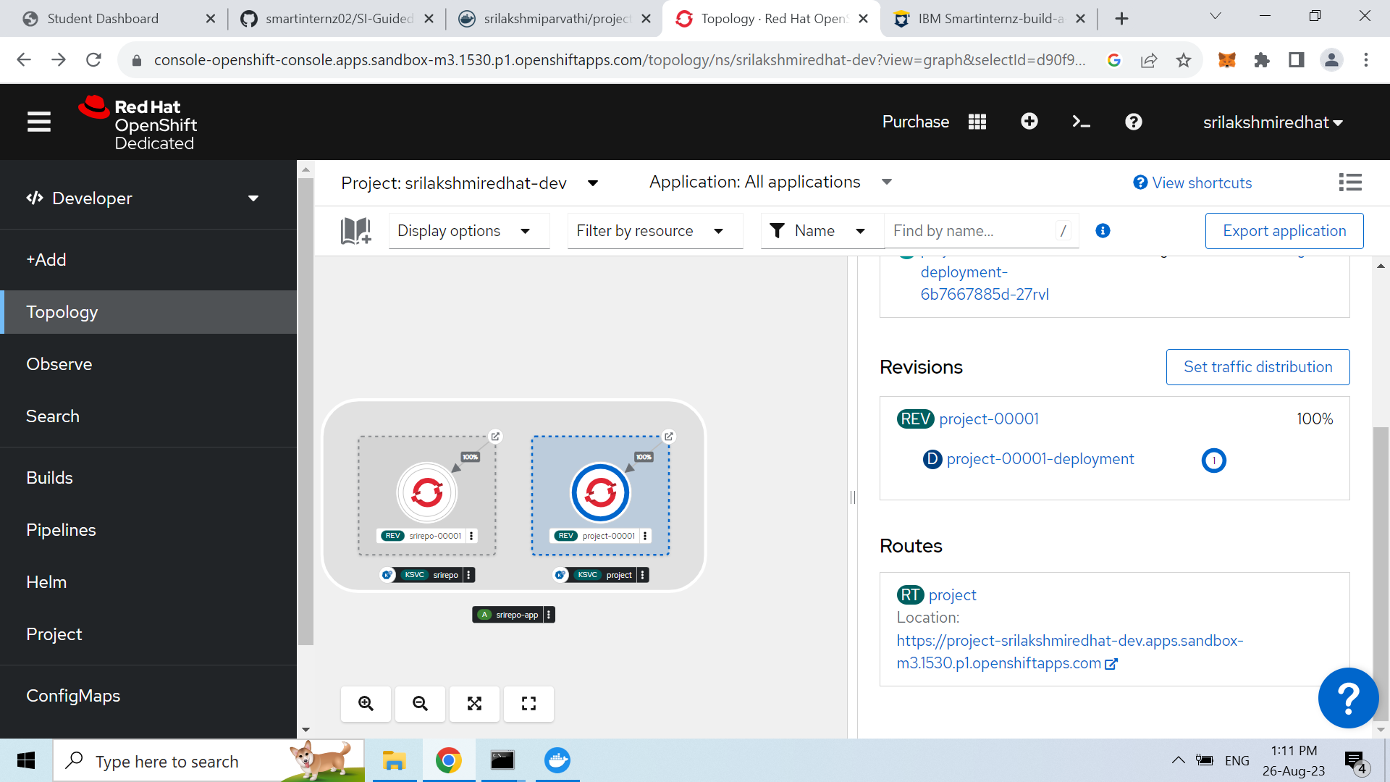

<https://project-srilakshmiredhat-dev.apps.sandbox-m3.1530.p1.openshiftapps.com/>

